Documentation for project by

Team CodeBreakers

Date of the document: 6.01.2021

Teammates

Stoyan Ponchev – Scrum Trainer

Boyan Binev - Q&A engineer

Atanas Burmov - Developer Backend

Valentin Petrov – Developer Frontend

Dimitar Georgiev – Code Checker

Raya Lilova – Documentary

Teachers

Danaila Stamatova – LITI

Petar Georgiev – LITI

Dimitrina Todorova – LITI

Table of Contents

1. Introduction 2
2. Purpose 3
3. Short description of the program 3
4. Used Programs 4
5. About the site 4
6. Diagram of the program 5
7. Table with the most important functions 6
8. Future Goals 7
9. Conclusion 7

# Introduction

We know that the documentation needs to be done carefully so the idea of our project to be clearly expressed to the ones who read it. Our project is a result of all of the ideas we’ve discussed and decided to make. We believe that the documentation can help to make the project more effective as it contains various information such as objectives, future goals, details about the project etc.

# Purpose

The purpose of this document is to present our project and our aim as clear as possible.

Our embassy was to deliver a game which helps the codebreakers to decode the coordinates of the German battleships so the allies will be able to track and destroy them. Our project represents a program with 2 levels (which level has 2 tasks) which the codebreakers should overcome and decode the coordinates of the German battleships. Also we thought it would be a good idea to create an attractive and interesting site that will arouse more interest.

# Short description of the program

Player 1 – (The Germans) – his role is to place a combination of 4 random numbers (0-7) and indicate the coordinates of German’s battleships.

Player 2 – (The code breaker) – his role is to guess the number within 13 tries.

End of the game – the game ends after 13 iterations or if the code breaker guessed correctly the numbers and positions.

# Used Programs

* The programs that we used for our project are:

1. Visual Studio – for writing the code.
2. Github – for storing the project.
3. Word and PowerPoint – for the documentation and Presentation.
4. Discord/Messenger/Teams – for communications and discussions.

* The program languages used for the project:

1. C++ - for develop the game.
2. HTML, CSS, JavaScript – for the site and the program.

# About the site

* **Main reason**

The main reason about our decision of making a site even if it isn’t necessary is that we want our project to be not just a task performance. We wanted our project to be fill with the ideas we have and a site was part of our list.

* **More popularity**

We thought it would be a good idea to make a site where the users could download our game and we are sure that would increase more popularity of the game.

* **Design**

The design has a big influence on the opinion that users have about the sites so that is the reason our site is as interesting as possible. The colors which are used don’t irritate the eyes. The text contrasts with the background for easier reading. We have to work more for achieving our expectation about the site (for more information about our future goals for the site check paragraph “Future Goals” in the end of the document).

# Diagram of the program

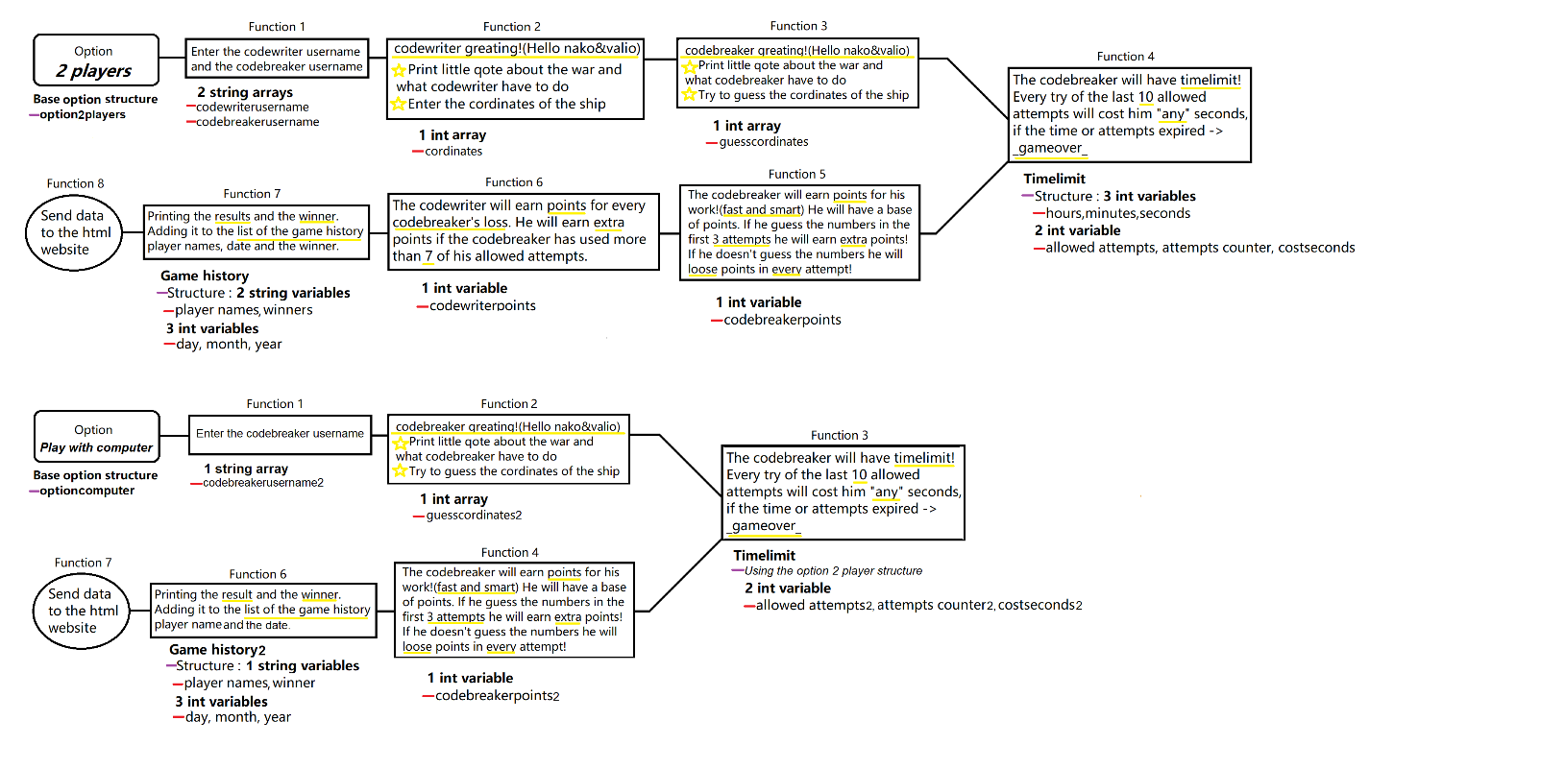

# Table with the most important functions

|  |  |  |  |
| --- | --- | --- | --- |
| Name (+ type) | Use | Arguments (+ type) | Returned value |
| void twoPlayers | This function clear the console then it opens an greeting page or just for a message and for entering the names. | OPTION2PLAYERS* player, int& option1counter, vector <int> var, int counterTries1, int option1CordinatesCounter, TIMELIMIT* timer, int timercounter | - |
| void timerFunction | Function which referees the time | clock_t time, TIMELIMIT* timer, int& timercounter | - |
| void checkM | Function for checking the input for the name | int& a | - |
| vector<char>inputGerman() | This function enter the coordinates of the German ships and it is type char because the function checks for letters. | - | return vGerman |
| void germanQote | This function checks if there are any incorrect elements or letters. Also it checks the range (0-7), it’s for the number of tries and for repeated numbers. | bool& flag, bool flag2, vector <char> German, vector <int>& var | - |
| vector<char>inputCodeBreaker() | Function for entering the coordinates of the code breaker’s guesses. | - | return vCodeBreaker |
| void checkingCoordinates | This function checks if there are any incorrect elements or letters. Also it checks the range (0-9) and the most important – which numbers coincide with the code breaker’s guess. | bool& flag, vector <char> codeBreaker, vector <char> German, vector <int>& var, int& points, int& counterTries1 | - |
| void germanQoteTask2 | Function for the second task of the first level. Checks for incorrect elements/letters, range (0-7) and for the tries. | bool& flag, bool flagRange, vector <char> germanRepeatable, vector <int>& varRepeatable | - |
| void checkingCoordinatesTask2 | For checking the coordinates for the second task of the level one Checks the repeated numbers. | bool& flag, vector <char> codeBreakerRepeatable, vector <int>& varRepeatable, int& points, int& counterTries2 | - |
| void repeatFunctionsTask2 | Function for repeat the actions with limit of 13 tries. | OPTION2PLAYERS* player, int option1counter, vector <int> var, int& counterTries1, int& option1CordinatesCounter | - |
| void storeInHtmlUk | Function for greeting the codebreaker. | OPTION2PLAYERS* player, int option1counter, vector <int> var, int counterTries1, int option1CordinatesCounter | - |
| void storeInHtmlGerman | Function for greeting the German. | OPTION2PLAYERS* player, int option1counter, vector <int> var, int counterTries1, int& option1CordinatesCounter | - |
| void checkingCoordinatesComp2 | Function for checking the correct coordinates. | bool& flag, vector <char> codeBreakerComp2, vector <int>& varComputer2, int& points, int& counterTries4 | - |

# Future Goals

If we all had infinite time to make all the programs in our heads, then they’d all include every feature in our list. This is where we get into the real planning. So what are our goals for our project? Firstly our main goal was to create a Rank List (In our site) where the top players’ names will be showed. Furthermore we want our game to develop (more levels and tasks, different players etc.) For site improvement our ideas are to add more information, more options in the menu, more pages, search engine – for easier way for consumers to find what are they searching for, online chat – where the users could communicate with us and ask questions. Also we thought it would be a good idea if there are a page with all the winners (who have been in the Rank List) and we believe that could make people to increase the popularity of our game. One more idea is for online comments – feedback that people will leave if the site was useful for them or if there are any improvements that they can offer. Another idea that we have about the site is to make it in other languages so that more people would visit it.

# Conclusion

To sum up we had a lot of ideas which we failed to accomplish in the time we had and we faced with many obstacles on the way to get the desired result but we are thankful to be part of this project because with every project we make we get better and learn new things every time but the most important – practice makes perfect. We have to work so much more to achieve the goals we have but for now we are pleased with the result. Who knows maybe one day we will make something that will reach all of the expectations we all have now. Stay tuned.

*LITI - Lecturer in Information Technology and Informatics